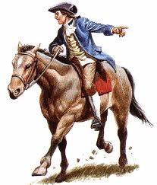C:\Documents and Settings\fkasukon\Local Settings\Temporary Internet Files\Content.IE5\N15V3NQN\MC910217270[1].wmfC:\Documents and Settings\fkasukon\Local Settings\Temporary Internet Files\Content.IE5\N15V3NQN\MC910217270[1].wmfC:\Documents and Settings\jfelts\Local Settings\Temporary Internet Files\Content.IE5\Z9OF38BM\MC900019782[1].wmfC:\Documents and Settings\jfelts\Local Settings\Temporary Internet Files\Content.IE5\Z9OF38BM\MC900019782[1].wmf

Benjamin Franklin

Benjamin Franklin

Paul Revere

Paul Revere

George Washington

George Washington

Glue here

Glue here

Glue here

Glue here

Glue here

Glue here